**CG1112 Engineering Principles and Practices for CEG**

**Alex Connection Guide**

1. Objective

The objective of this guide is to help you connect up Alex’s key components. **YOU MUST READ THROUGH THIS ENTIRE DOCUMENT BEFORE STARTING OR YOU WILL MAKE TIME-CONSUMING MISTAKES THAT REQUIRE YOU TO DISMANTLE AND REASSEMBLE EVERYTHING.**

1. The Alex Challenge

**The Basic Alex Challenge**

In the Alex Challenge, you will be building a robot named Alex that is controlled over the internet (or “over the cloud” as many clueless-noobs-pretending-to-be-tech-experts are wont to say). Alex will be carrying a Light Detection and Ranging (LIDAR) unit that will map the surrounding area (as well as preventing him from crashing into walls and other objects).

You are to use Alex to explore and map out a room remotely. How remotely? Literally in any part of the world, from Singapore. However due to the realities of budget constraints, Alex will be in the DSA Lab but you will control pilot “blind” from another part of the lab.

As you control Alex, he will be streaming back a live map of the room he is in, and you will display the map on your screen and map the room out for us.

You will be scored on how well you map the room within a given time frame.

1. Preliminaries

Charge the Eneloop batteries and the power bank.

1. Assembling Alex
2. Locate the Magician Chassis packet. It contains components that look like this:

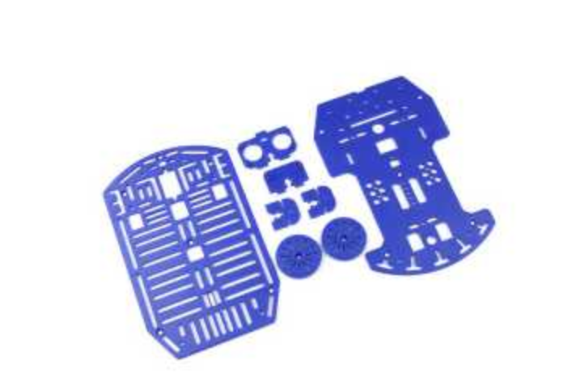

1. Unpack the contents of the Magician Chassis, and remove the Assembly Instructions for your reference. It is a piece of paper that looks like this:

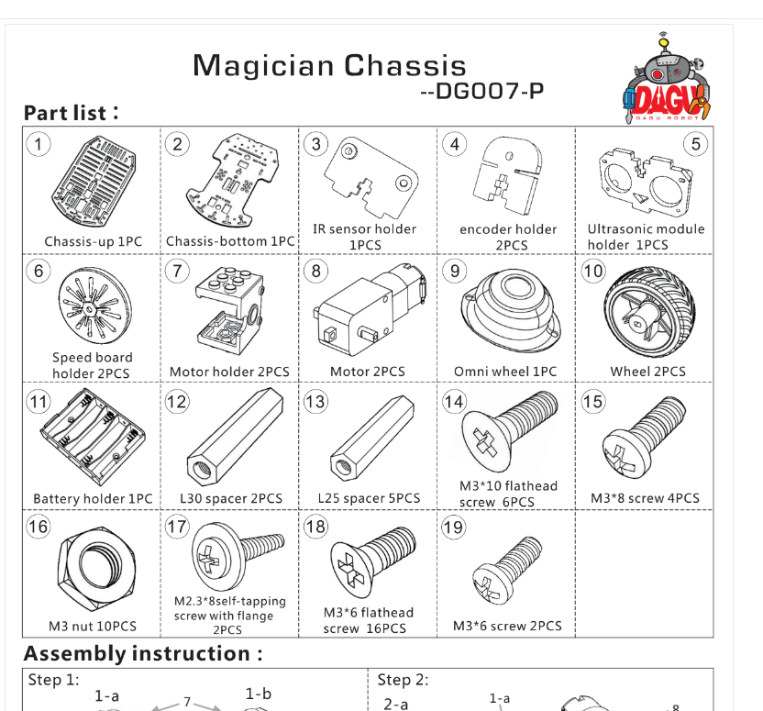

1. Follow the instructions on the sheet, but:
2. SKIP Steps 1 and 2

|  |  |
| --- | --- |
|  |  |

1. In Step 7, DO NOT mount the center spacer and the ultrasonic sensor holder.

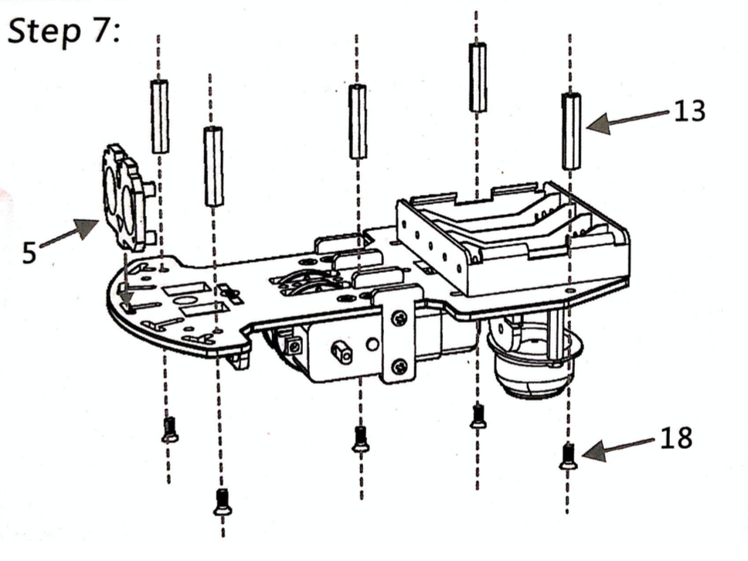

1. Do not mount the top plate (Step 8) until you have finished planning your layout.
2. Locate the Wheel Encoder packet. The contents of the Wheel Encoder Packet look like this. The two silver/black disks are four-pole magnets, while the two skinny black objects with the red, white and black wires are Hall Effect sensors. The idea is that when the wheel turns the magnets, the Hall Effect sensor will detect the magnets and trigger pulses.

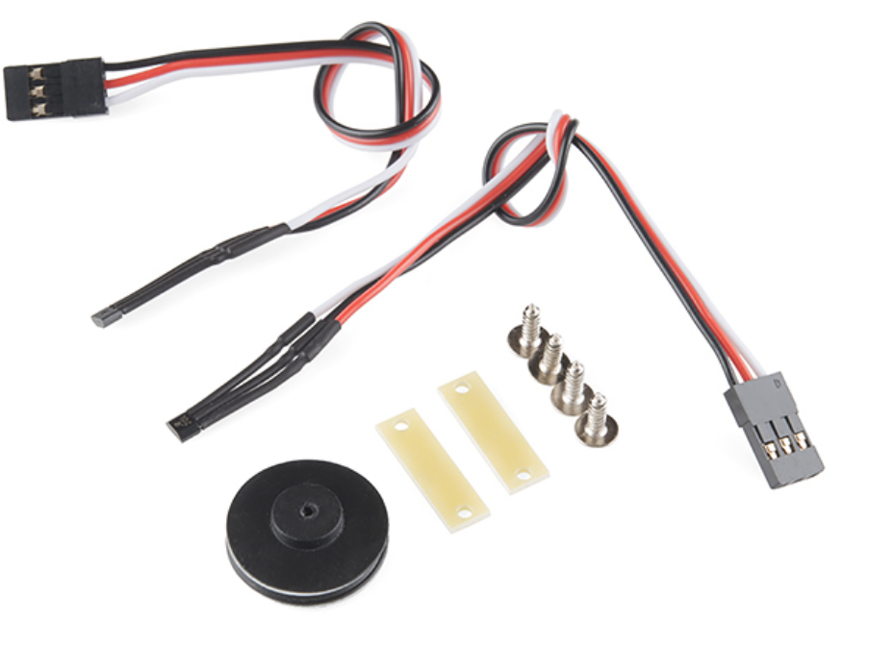

1. Unpack the Wheel Encoder, and mount one magnet and one encoder on each motor, using the following picture as guide. If you do not have a cable tie, get creative. The magnet and encoder are circled.

(WARNING: Ensure that the sensors do not touch the magnets after mounting. The gearbox will multiply the friction by 48x and make it impossible to turn the wheels)

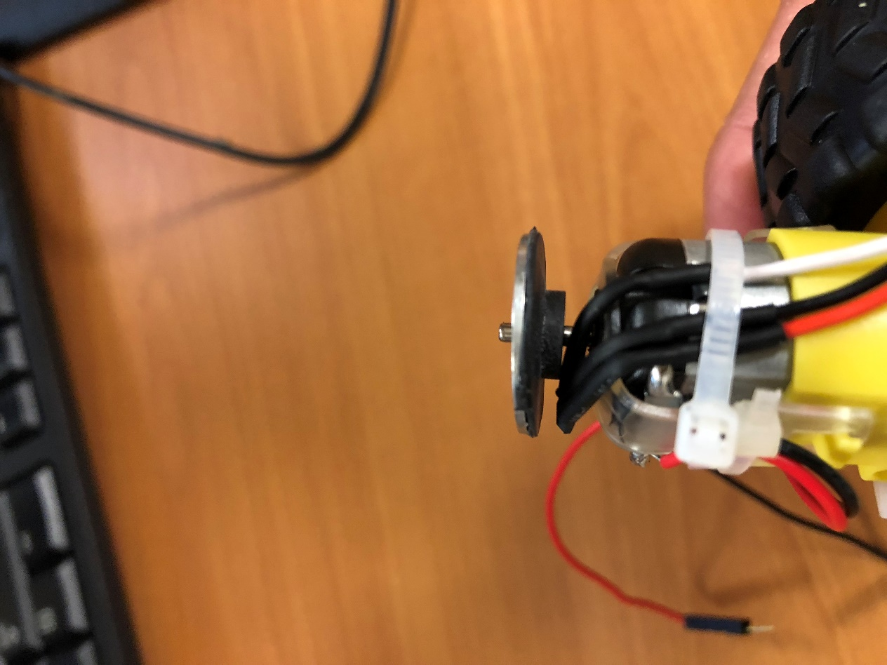

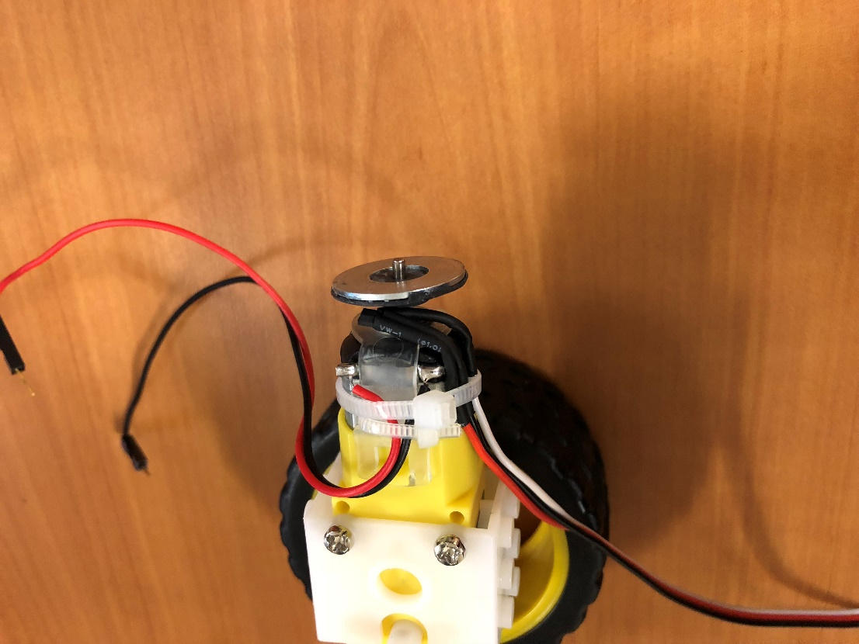

**NOTE: This motor uses a 48:1 gear to drive the wheels, so whatever reading you get from the encoder, remember to divide by 48 to get the actual reading. Also if the sensors touch the magnets the wheels will NOT be able to turn, because the friction between the magnet and the sensors will be multiplied 48x by the gearbox.**

1. Connecting the Electronics
2. **READ THROUGH THIS WHOLE SECTION AND PLAN HOW TO LAYOUT YOUR ELECTRONICS AND ELECTRICALS ON THE MAGICIAN CHASSIS BEFORE STARTING. IF YOU DON’T, IT IS VERY LIKELY YOU WILL NEED TO DISMANTLE SOMETHING AND RESTART AGAIN. VERY FRUSTRATING. DON’T SAY WE DIDN’T WARN YOU.**
3. Assemble the DRV-8833 Dual Motor Driver Carrier:
   1. Locate the packet containing the DRV-8833. It looks like this:

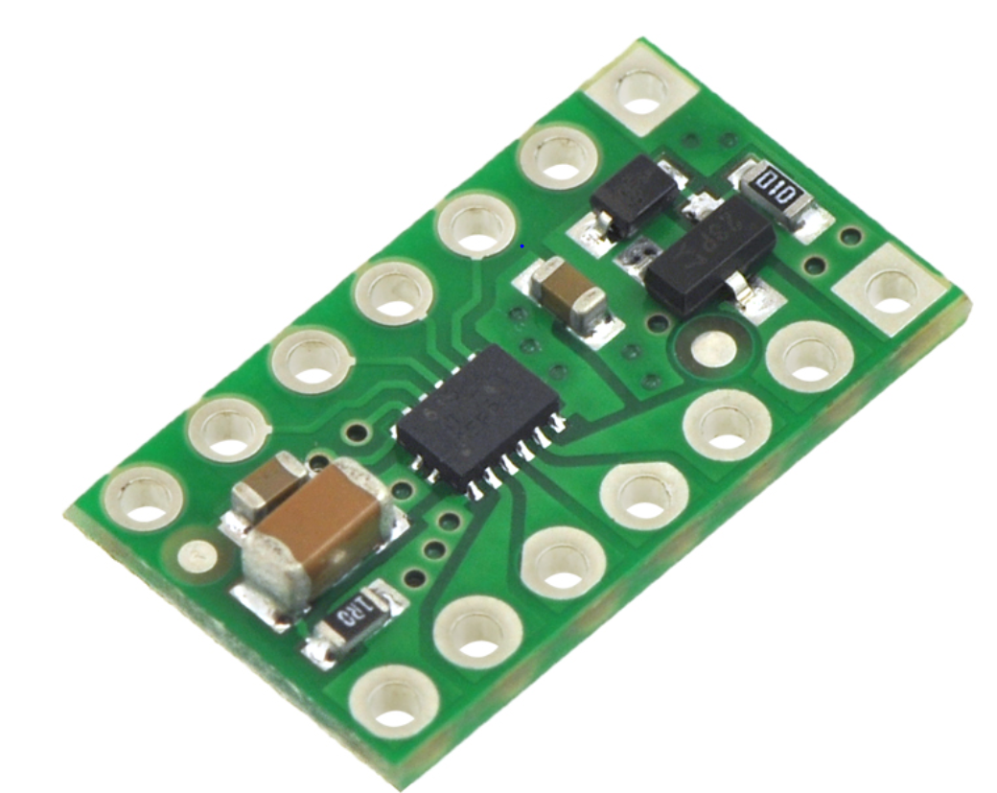

* 1. Solder on the pin headers. You can solder them on either side of the board, but it’s a good idea to solder so that you can still see the labels, as shown circled below:

`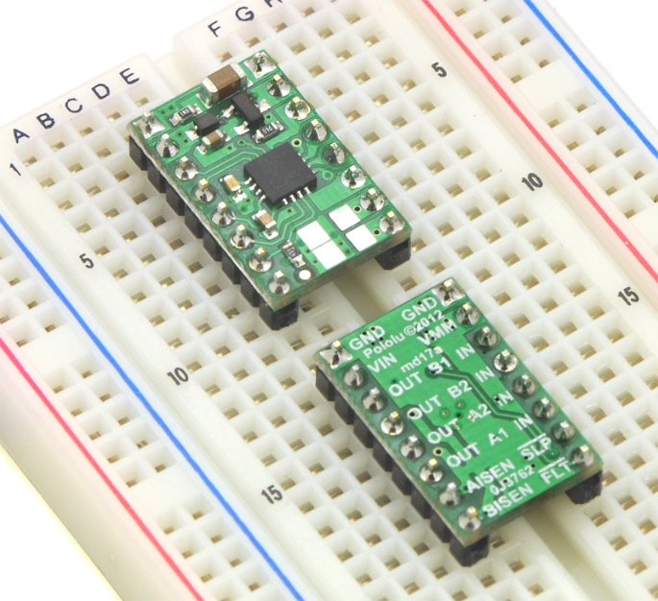

1. Connecting the motor power:

Connect the battery carrier male plug to the inline switch’s female jack, and the plug on the inline switch’s male plug into the 2.1 mm female jack provided.

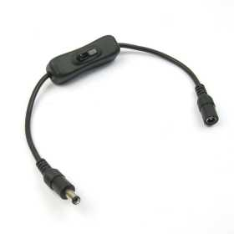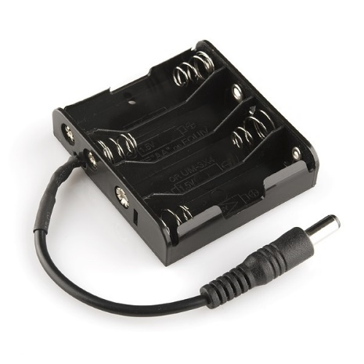

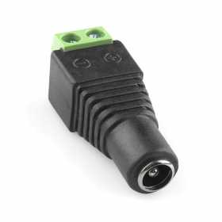

1. Connecting Up the DRV-8833 Dual Motor Driver Carrier.

We will now connect up the DRV-8833 Dual Motor Driver Carrier. The DRV-8833 contains a pair of H-bridges that will drive the motors. You will need to connect TWO power supplies to the DRV-8833. VIN and GND (on the same side as VIN) will be connected to the four Eneloop batteries to supply power to the motors. VMM and GND (on the same side as VMM) will be connected to the 5v and GND on the Arduino.

The remaining pins are connected either to the PWM outputs on the Arduino, or to the motors.

Step 1

We would like to standardize how you connect the motors to the DRV-8833, so to begin:

Place the Magician Chassis on the lab bench with the curved end facing AWAY from you (the curved end will be Alex’s front.)

The left motor will be designated as MOTOR 1, and the right as MOTOR 2.

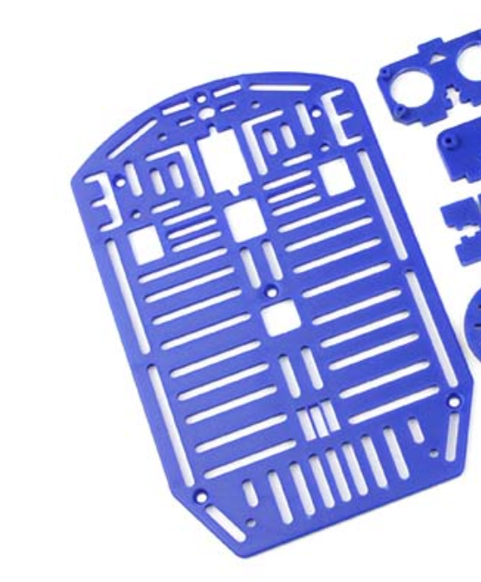

Alex’s front. Place Alex on bench, wheels down, with the front facing AWAY from you.

Step 2

Mount the DRV-8833 on a breadboard.

Connect up the DRV-8833 this way:

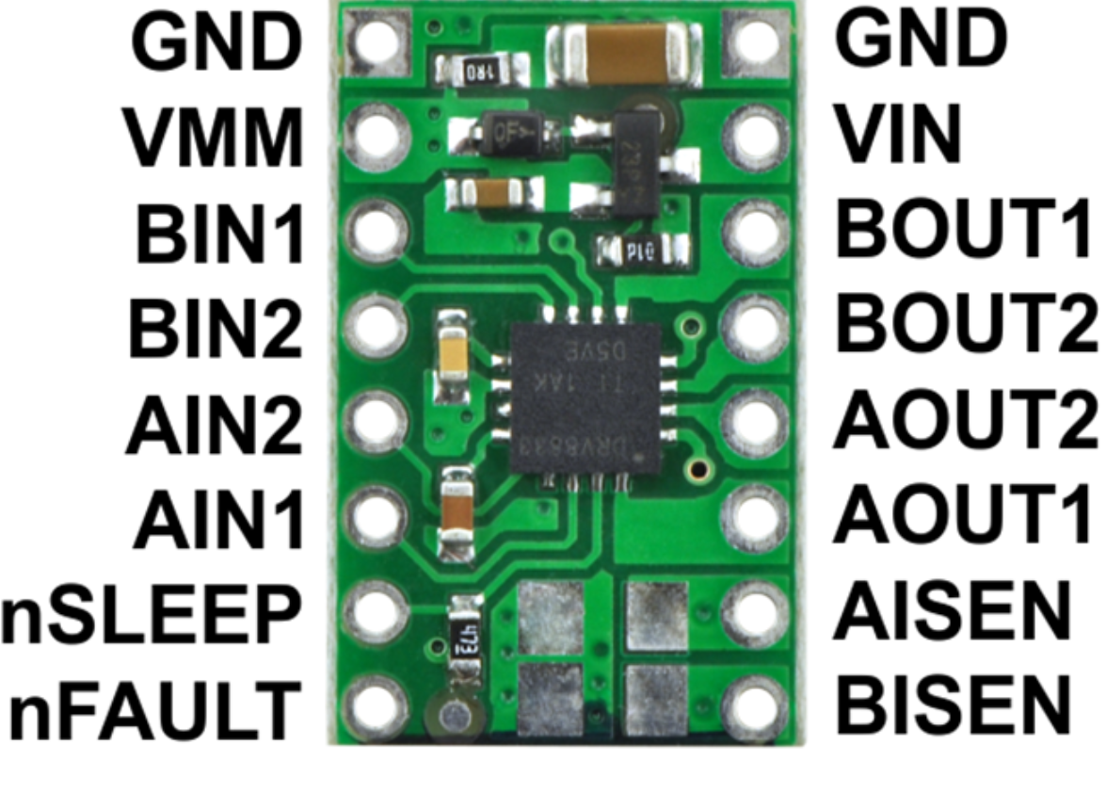

|  |  |  |
| --- | --- | --- |
| Pin | Description | Connect to: |
| VIN | Motor Power Supply VCC | + screw of the 2.1mm female jack |
| GND (right side) | Motor Power Supply GND | - screw of the 2.1mm female jack |
| BOUT1 | Motor 2 +ve | Red wire from RIGHT motor. |
| BOUT2 | Motor 2 –ve | Black wire from RIGHT motor. |
| AOUT1 | Motor 1 +ve | Red wire from LEFT motor. |
| AOUT2 | Motor 1 –ve | Black wire from LEFT MOTOR |
| VMM | VCC from Microcontroller | Do not connect. |
| GND (left side) | GND from Microcontroller | GND on Arduino UNO |
| BIN1 | Motor 2 control | Arduino pin 10 |
| BIN2 | Motor 2 control | Arduino pin 11 |
| AIN1 | Motor 1 control | Arduino pin 5 |
| AIN2 | Motor 1 control | Arduino pin 6 |

Leave the remaining pins unconnected.

Now when you do analogWrite on pins 5 and 10, Alex will run in one direction (yet to be determined), and when you do analogWrite on pins 6 and 11, he will run in the opposite direction.

1. Connecting the Wheel Encoders
   1. Wheel encoder power supply:

Both wheel encoders come with a 3-way cable, with red and black wires. These supply power to the Hall Effect sensor that is used to detect how many revolutions the wheel makes.

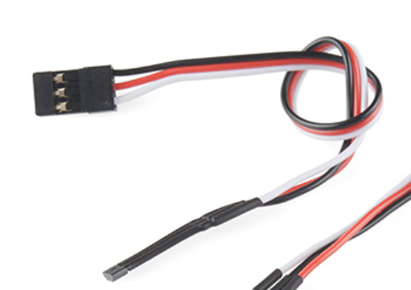

Connect the red wire of both encoders to 5V on the Arduino, and the red wire of both encoders to the GND on the Arduino.

* 1. Wheel encoder signal:

Ensure that Alex’s front is away from you.

Connect the white wire from the encoder mounted on MOTOR 1 (left motor) to **pin 2** of the Arduino, and the white wire from the encoder mounted on MOTOR 2 (right motor) to **pin 3** of the Arduino.

If you recall from Week 5 Studio 1, pins 2 and 3 are external interrupts INT0 and INT1 respectively. This way when the wheel turns, the pulses generated will trigger interrupts on the Arduino that can be caught with ISRs.

1. Connecting up the Arduino UNO

Use the full sized USB cable to connect the UNO to one USB port of the Raspberry Pi.

1. Connecting up the Raspberry Pi

Step 1. Power Up

Use the micro-USB cable and power up the Pi with the power bank.

Step 2. Configure Pi for SSH Access

Configure the Raspberry Pi as per Week 1 Studio 1. Ensure that you can ssh into your Pi using any of the techniques in that Studio.

Step 3. Power Down

At the terminal, type:

sudo halt

Wait for about 10 seconds for the Pi to fully halt, then unplug it from the power bank

1. Now that you have read through everything and know how everything snaps together, plan out how you want to lay out Alex’s electronics. You can use any available space on the chassis. It is a challenge but it can be done. NOTE: You also need to budget space (or figure out a way) to mount the LIDAR in a future studio. Mechanical dimensions (in mm) for the LIDAR are shown below:

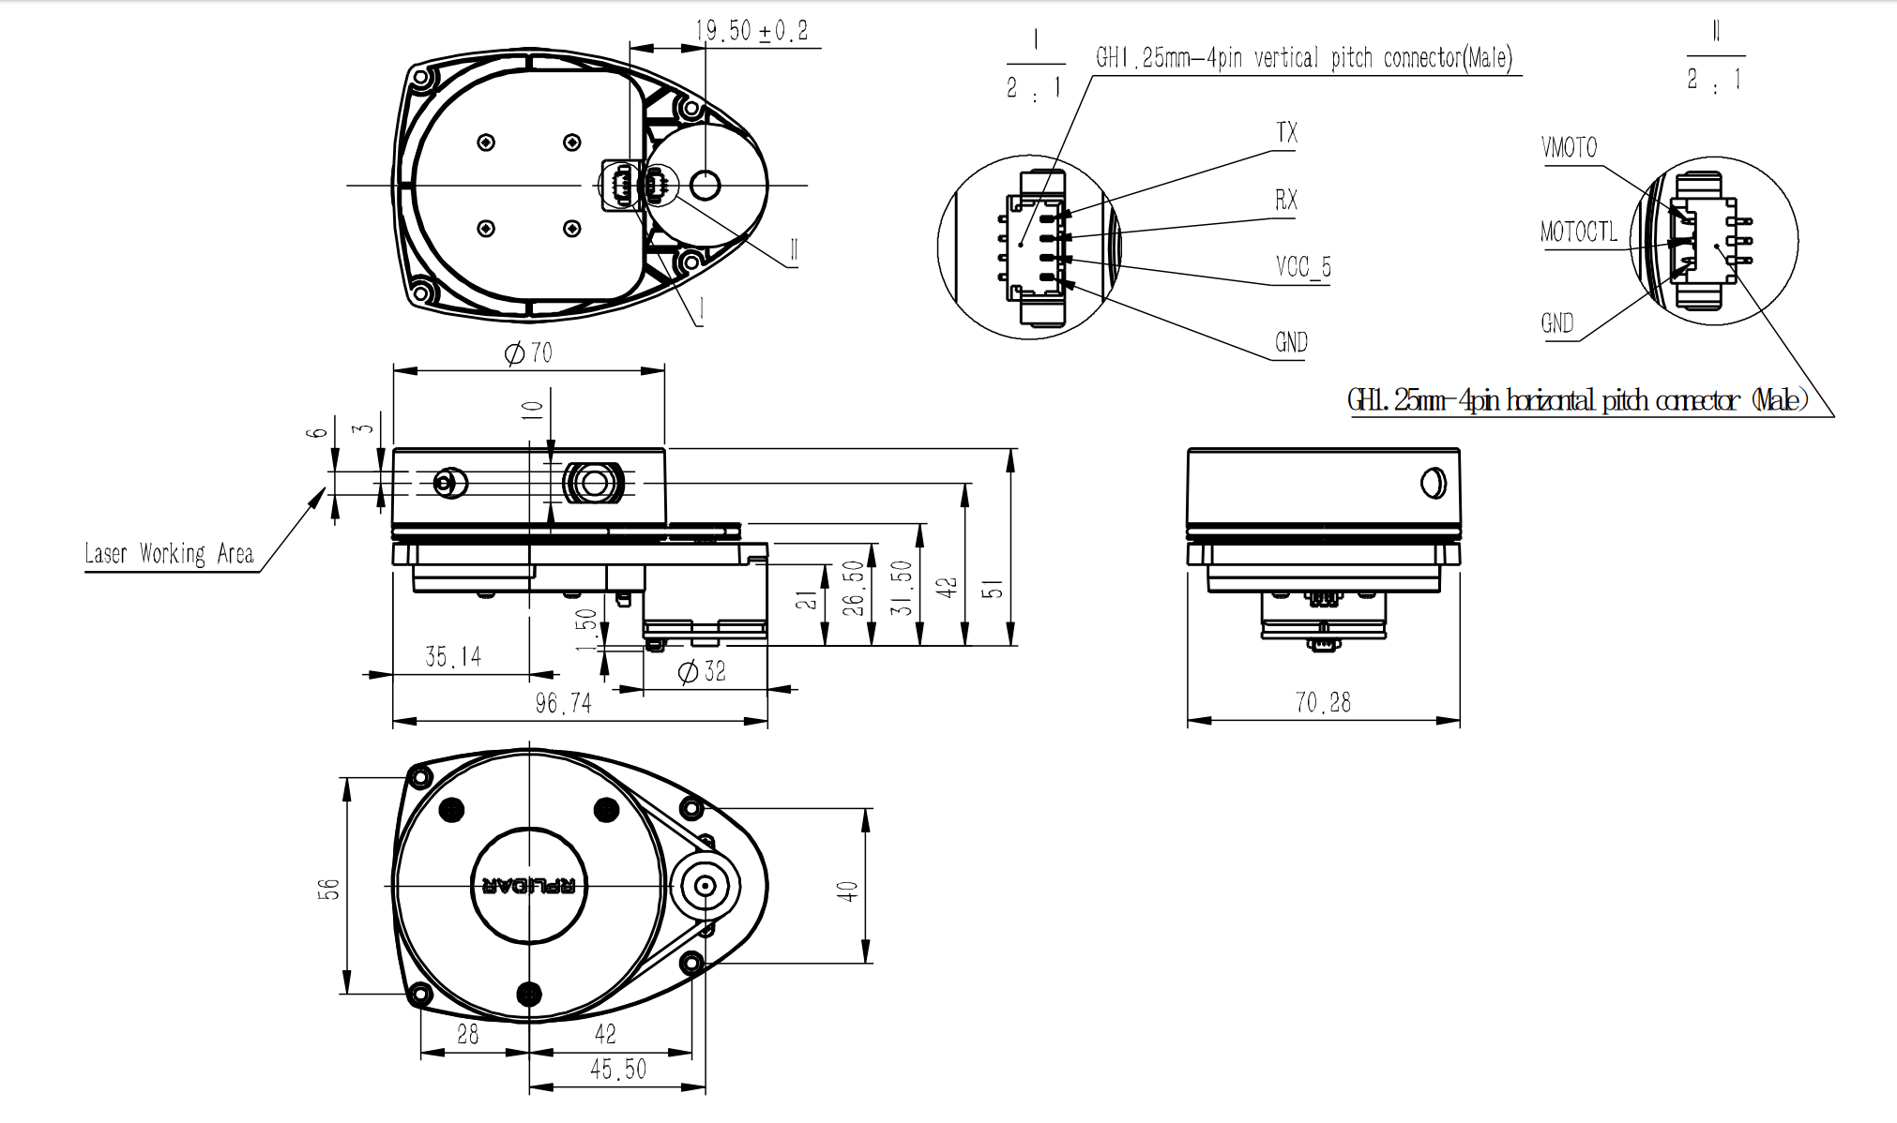

1. Lay out and secure all of your components on the chassis using double-sided tape, cable ties or other methods of your choice.
2. Finish assembling the chassis as per the assembly guide.
3. Programming Alex

Start the Arduino IDE and load the enclosed sketch called Alex.ino.

Click on the robotlib tab, and you will see the code for programming Alex. In particular there are 4 constants:

M1F, M1R: Motor 1 forward and reverse Arduino PWM pins.

M2F, M2R: Motor 2 forward and reverse Arduino PWM pins.

You may need to tweak these later.

1. Testing Alex

Step 1. Unplug the Arduino from your laptop and connect it to the Raspberry Pi.

Step 2. Ensure that the inline switch is off.

Step 3. Insert the AA Eneloop batteries into the battery holder.

Step 4. Connect the Pi to the power bank.

Step 5. Switch on the inline switch.

You will now see Alex running around like a drunken proboscis monkey. He will move forward, turn left, move backwards, turn right, and stop for 2 seconds, then repeat his drunken behaviour.

If he is turning or moving in the wrong direction, adjust M1F, M1R, M2F and M2R until he is behaving correctly.